**BRAZIL ETS AT A GLANCE**

|  |  |
| --- | --- |
| Years in operation | The Brazilian ETS (SBCE, in Portuguese), approved 2024, will be implemented in five major phases:   * Phase 1: Initial regulatory setup (2025-2026) * Phase 2: MRV system operationalization (2026) * Phase 3: Mandatory emissions reporting and monitoring plans (2027-2028) * Phase 4: Pilot phase: first allocation cycle and initial trading * * Phase 5: Full market operation**   * First National Allocation Plan (NAP, minimum 12 months duration).  ** Begins after the conclusion of the first NAP. |
| Overall cap & trajectory | Cap to be defined by the NAP, approved at least 12 months before each cycle, adopting a progressive path to estimate two future compliance periods. |
| Target(s) | In line with Brazil’s National Policy on Climate Change (PNMC) and the commitments assumed under the UNFCCC.  The SBCE is conceived as a key policy tool to support Brazil’s NDC, offering a potential mechanism to provide price signals and compliance incentives for emissions reductions in carbon-intensive sectors. The Brazilian NDC is currently structured as follows:   * By 2030: 1.2 GtCO2e (53.1% below 2005) (2030 NDC) * By 2035: between 850 MtCO2e and 1.05 GtCO2e * By 2050: Long-term objective to achieve climate neutrality by 2050 (stated in the 2030 NDC).   The law and current regulation do not yet explicitly define the quantitative or structural role the SBCE will play in meeting the country's NDC targets. |
| Emissions reduced to date | |  | | --- | | Not applicable (system not yet operational). |  |  | | --- | |  | |
| Sectors covered | |  | | --- | | Awaiting complete definition during regulation phase. However, primary agricultural production and indirect emissions from agricultural inputs are excluded. Facilities in the waste sector may also qualify for exemption if they employ verifiable emission-neutralization technologies. Therefore, the economy-wide system shall cover, up to this point, the following sectors:   * Maritime * Mining and extractives * Waste * Domestic Aviation * Transport * Industry * Power | |
| GHGs covered | |  | | --- | | CO₂, CH₄, N₂O, HFCs, PFCs, SF₆, and others under the UNFCCC. | |
| # of covered entities | |  | | --- | |  |  |  | | --- | | To be defined by regulation under the preliminary thresholds:   * Entities emitting between 10,000 tCO₂e/year and 25,000 tCO₂e/year for MRV reporting; * Entities emitting over 25,000 tCO₂e/year for full compliance obligations. |     Obligations will apply only to activities for which consolidated, robust MRV regulations are available.  National Allocation Plans should clearly define the level at which caps will be applied, whether to installations, facilities, or economic groups, as this decision has direct implications for environmental integrity, administrative complexity, and cost efficiency. |
| Allocation method | Brazilian Emission Quotas (CBEs, in Portuguese) will be allocated through free distribution (especially during initial phases), auctions or other paid mechanisms with caps defined in the NAP. |
| Administrating Entity | Interministerial Committee on Climate Change (CIM, in Portuguese) |
| Main Legal Instrument | Federal Law No. 15,042/2024 |
| Trading rules | Currently, as per SBCE law provisions, while the Interministerial Committee on Climate Change is responsible for defining the conditions for authorization, it is the SBCE Managing Body the one responsible for defining methodologies allowed to generate *Certificado de Redução ou Remoção Verificada de Emissões* (CRVEs).  Allowances and CRVEs, when traded on financial and capital markets, are securities subject to relevant laws and to the Brazilian Securities and Exchange Commission. |
| Use of offsets and linking | CBEs may be used for compliance in the same or future periods, as regulated by the SBCE Management Body and approved in the PNA.  Use of SBCE assets for voluntary carbon offsetting requires their cancellation in the system’s Central Registry.  Covered entities will be allowed to surrender domestic offset credits to meet part of their compliance obligation.   * Eligible activities are those that make use of methodologies accredited by the SBCE management body (to be determined); verified by an independent entity; and registered in the SBCE Central Registry. Once registered in the SBCE registry as CRVEs, the offset credits will become eligible for use under the SBCE. * No approved independent crediting mechanisms or methodologies so far. Paris Agreement Crediting Mechanism (PACM) methodologies expected to be approved.   Currently not linked to other instruments. |
| Other features | **CRVEs and Voluntary/International Use**:   * Carbon credits generated in Brazil and used for **international transfers of mitigation outcomes** (under Article 6 of the Paris Agreement) must be registered as **CRVEs** in accordance with SBCE rules and require **prior authorization** from Brazil’s designated national authority. * Any use of SBCE assets (including CBEs or CRVEs) for **voluntary corporate or individual offsetting** requires their **permanent cancellation** in the SBCE’s central registry (Art. 45), ensuring environmental integrity and preventing double counting. |
| Penalties for non-compliance | Entities subject to a range of sanctions, warnings, fines (up to 3% of annual gross revenue, or BRL 20 million for non-corporate entities), public disclosure of infractions, suspension or shutdown of activities, and restrictions on rights such as licenses, financing, or public contracts. |
| Use of revenues | All SBCE revenues must be allocated in the following order of priority:   * At least 15% for the system operation and maintenance; * At least 75% to the National Climate Change Fund, to finance decarbonization investments in regulated activities, sources, and installations, to be defined by regulation; * At least 5% to compensate traditional communities for conserving native vegetation and ecosystem services. |

**MAJOR DEVELOPMENTS**

In 2024, Brazil took a decisive step by approving Law No. 15.042/2024, which formally establishes a national regulated carbon market, known as the Sistema Brasileiro de Comércio de Emissões (SBCE). This framework provides the legal basis for mandatory emissions trading, robust MRV protocols, penalties for non-compliance, among other key regulatory and operational instruments.

Since the beginning of 2025, Brazil has been implementing the first of five planned phases under the SBCE Roadmap. This phase, lasting twelve to twenty-four months, is dedicated to setting up the market’s managing authority and establishing clear institutional arrangements for coordination with other relevant agencies, with a transitional body expected to guide this governance architecture in the short term. A technical-scientific advisory committee will provide guidance and ensure transparency throughout this process. Successful completion of this phase will translate the legal framework into clear technical rules for the subsequent implementation of pilot activities and the gradual transition to a fully operational market with binding emissions caps.

A technically significant mandate under Article 56 of Law 15.042/2024 – later amended by Law 15.076/2024 – requires insurers, pension entities, capitalization companies, and legal reinsurers to allocate at least 0.5% of their annual technical reserves and provisions in environmental assets (namely, those classified as carbon credits, according to the Law) or through investment funds earmarked for such assets. This requirement establishes a recurring, institutional demand stream, with the potential to allocate BRL7–9 billion to carbon credits or related funds, according to estimates by SUSEP, the sector's regulatory agency. While the sector has raised concerns regarding market liquidity and constitutional compliance, the provision is poised to enhance demand-side stability.

Brazil’s updated Nationally Determined Contribution (NDC) underlines the urgency of operationalizing the SBCE: national emissions are projected to reach approximately 1.32 gigatonnes CO₂ equivalent in 2025 and must decline to around 1.20 gigatonnes by 2030, with a conditional pathway to 0.85 gigatonnes by 2035 if supported by international finance and technology transfer. The regulated market is a central instrument for closing this gap in a cost-effective manner, mobilizing private capital toward high-quality emissions reductions and large-scale low-carbon technologies.

This year’s regulatory push is framed by Brazil’s strategic objective to present concrete progress at COP30, to be hosted in Belém in November 2025. Attention will also focus on ensuring interoperability between Brazil’s voluntary and compliance carbon market frameworks, as well as on the mechanisms for linking the domestic system to international carbon markets, particularly through the operationalization of Article 6 of the Paris Agreement.

The full design, milestones, and institutional steps for the SBCE are outlined in the official Roadmap released by the Brazilian government.

**MARKET COMMENTARY**

The SBCE’s offset mechanism offers significant potential to channel private sector capital into **c**ost-effective natural climate solutions (NCS) such as forest conservation, reforestation, agroforestry, and restoration of degraded lands, as well as low-carbon technologies and eligible mitigation activities. By allowing regulated entities to partially meet their compliance obligations through the purchase of verified offsets, the system creates a direct financial incentive for investment in emission reductions beyond the industrial core, particularly in land-use sectors where mitigation costs are often lower and co-benefits (e.g., biodiversity, water security, local livelihoods) are high. Given Brazil’s vast natural ecosystems and carbon-rich biomes, especially in the Amazon and Cerrado, a well-governed offsets market under the SBCE could unlock large-scale climate finance for both innovative low-carbon production technologies and NCS projects, while also supporting the participation of indigenous and traditional communities in the carbon economy, provided that robust safeguards, MRV standards, and benefit-sharing mechanisms are firmly in place.

Brazil’s voluntary carbon market is poised to play an increasingly strategic role in global decarbonization efforts, with its vast natural assets, project maturity, and growing policy alignment positioning the country as a key supplier in the years ahead. Below are the projected voluntary carbon credit issuances in Brazil by project sector through 2050, aggregating data from 11 major standards—including Verra (VCS), CDM, ART, Cercarbono, and others—as well as unregistered carbon dioxide removal (CDR) projects. The forecast is standard-agnostic and based on modeled market dynamics.

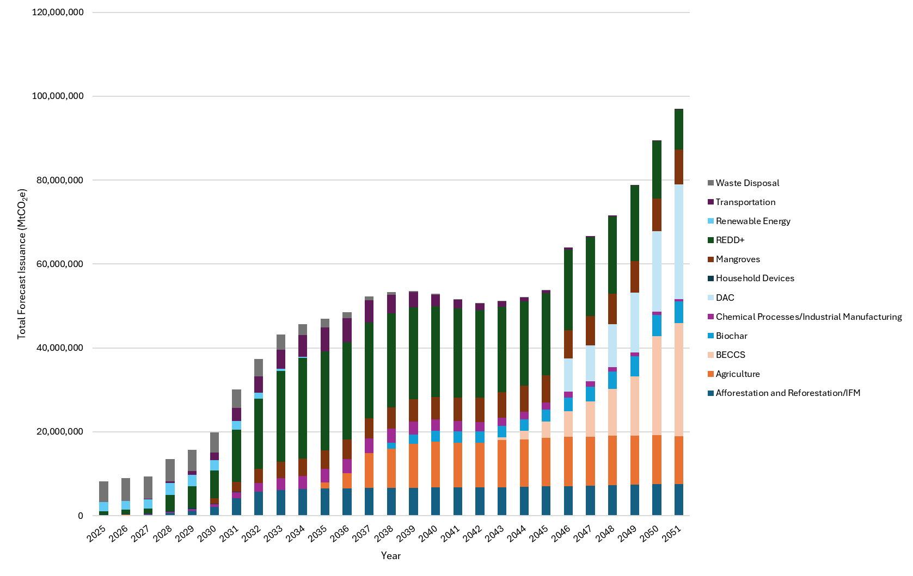

Figure 1 - Total Forecast Issuances in the Voluntary Carbon Market in Brazil, by project sector.

Source: AlliedOffsets

Furthermore, one critical aspect to the successful implementation of the SBCE is the efficiency in the publication and availability of data within national inventories, not only to ensure transparency and environmental integrity, but also to enable regulated companies to plan their compliance strategies and allocate resources effectively. Clear, timely, and accessible information, especially on the current emission level per sector, is crucial for companies to forecast compliance costs, design mitigation projects, or engage in secondary market transactions with predictability. Delayed data releases or lack of regulatory clarity can create uncertainty, distort carbon prices, and undermine investments in energy efficiency, innovation, and nature-based solutions. Therefore, the success of the SBCE will also depend on a robust, reliable data infrastructure that responds to the operational needs of market participants.

Brazil also hosts great potential to supply Internationally Transferrable Mitigation outcomes (ITMOs), either for use under Article 6.2 of the Paris Agreement or other international uses, such as the Carbon Offsetting Scheme for International Aviation (CORSIA). CORSIA is a global initiative to cap aviation emissions at 2019 levels, implemented in three phases: a pilot phase (2021–2023), a first phase (2024–2026), and a mandatory phase (2027–2035) for most international routes. To comply, airlines must purchase eligible emissions units from ICAO-approved programs, which must meet stringent criteria for additionality, permanence, robust MRV, and avoidance of double counting, thus requiring corresponding adjustments from host countries, similar to Article 6.2’s ITMOs. As per TNC’s “[Article 6 Explainer](https://www.nature.org/content/dam/tnc/nature/en/documents/TNC_Article_6_Explainer.pdf)”, total cumulative demand for ITMOs by both buying countries and airlines compliant to CORSIA shall reach 685 MtCO₂e by 2030.

According to estimates by AlliedOffsets, the chart below presents forecasted issuances of Brazilian carbon credits potentially eligible under the first phase of CORSIA, broken down by purchasability year through 2031. All credits must undergo corresponding adjustments to qualify, meaning that while these projections reflect potential supply, actual eligibility will depend on formal government authorization and proper registry procedures for adjustment.

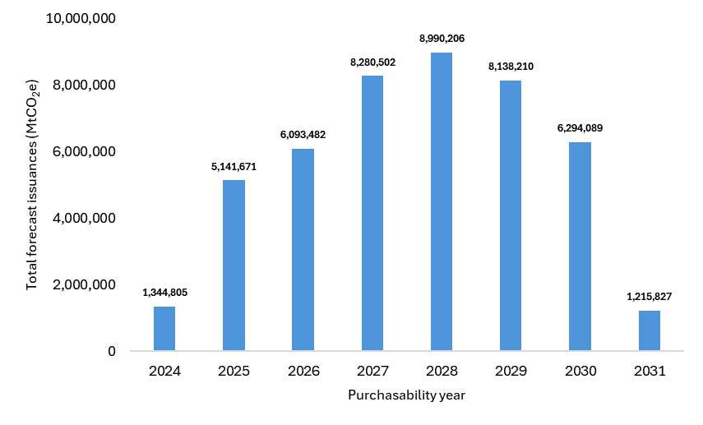

Figure 2 - Forecast CORSIA First Phase-Eligible issuances in Brazil.

Source: AlliedOffsets

**USEFUL LINKS**

[Carbon Market – Ministry of Finance](https://www.gov.br/fazenda/pt-br/assuntos/noticias/2024/dezembro/conheca-mais-detalhes-das-cinco-fases-de-implementacao-do-mercado-de-carbono-no-brasil)

[Lei 15.042/2024](https://www.planalto.gov.br/ccivil_03/_ato2023-2026/2024/lei/L15042.htm)

[Lei 15.076/2024](https://www.planalto.gov.br/ccivil_03/_ato2023-2026/2024/lei/L15076.htm)

[Plano Clima](https://www.gov.br/mma/pt-br/composicao/smc/plano-clima)

[Brazil’s Nationally Determined Contribution (2024)](https://unfccc.int/sites/default/files/2024-11/Brazil_Second%20Nationally%20Determined%20Contribution%20%28NDC%29_November2024.pdf)

**REFERENCES**

[ICAP Fact Sheet - Brazilian Emission Trading System](https://icapcarbonaction.com/system/files/ets_pdfs/icap-etsmap-factsheet-79.pdf)

[Article 6 Explainer](https://www.nature.org/content/dam/tnc/nature/en/documents/TNC_Article_6_Explainer.pdf)

[Capital Reset - *Seguradoras terão que destinar R$ 9 bi para créditos de carbono*.](https://capitalreset.uol.com.br/financas/investimentos/seguradoras-terao-que-destinar-r-9-bi-para-creditos-de-carbono/)

**AUTHORS**

IETA staffer  
Job title, IETA  
email

Juliana Damasceno  
Executive Manager, ACX Brasil  
[juliana@acx.net](mailto:juliana@acx.net)

Fundile Maphanga  
Policy Lead, AlliedOffsets  
[fundi.maphanga@alliedoffsets.com](mailto:fundi.maphanga@alliedoffsets.com)

Daniel Blum  
Carbon Policy Analyst, AlliedOffsets  
[daniel.blum@alliedoffsets.com](mailto:daniel.blum@alliedoffsets.com)